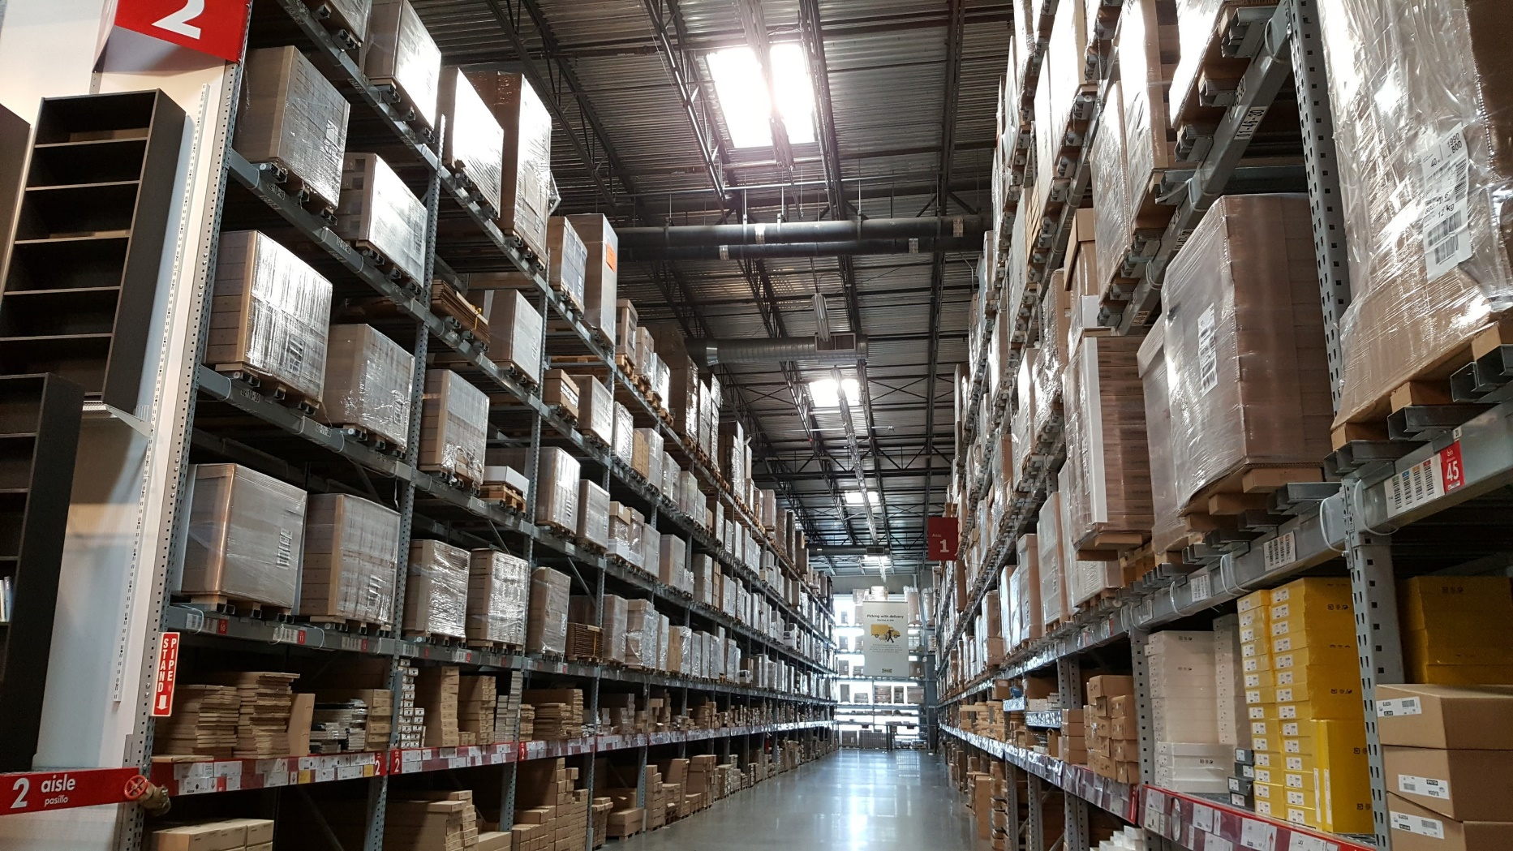

Small in size, big in attitude…the CL-S400DT From Citizen!
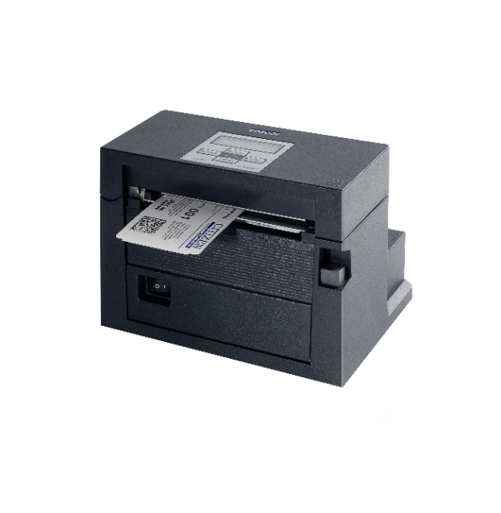
The unparalleled CL-S400DT is designed and engineered to be flexible and functional in different areas including operations, ticketing, labeling and logistics. This printer effortlessly prints at six inches per second and can handle a wide range of media. Designed to accommodate variable media outside diameters, utilizing a metal print mechanism and a time proven high-quality product design, the CL-S400DT provides protection against costly down time.

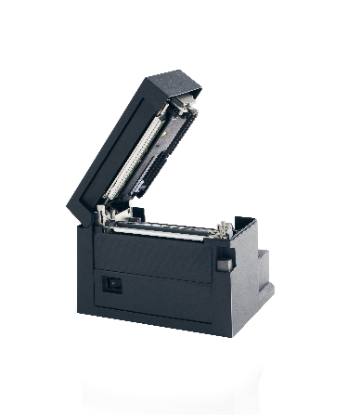

For more information on specification or a sample unit
contact us at info@citizen-systems.com

Make sure to follow us on LinkedIn https://www.linkedin.com/company/citizen-systems-america

Citizen is dedicated to supporting the efforts of containing and defeating the COVID-19 outbreak. A portion of our printer sales will be directly donated to the CDC Foundation’s Research & Support Fund.
Citizen Systems America
363 Van Ness Way Suite 404
Torrance, CA 90501
www.citizen-systems.com

